Ministry of Health
2012
Climate Change Strategic Plan for Public Health
Towards Increased Climate Resilience for Better Health and Well Being of All Cambodian
Health Working Group for Climate Change, September 2012
#151-153, Kampuchea Krom Avenue, 12252, Phnom Penh

Executive Summary

The Climate Change Strategic Plan for Public Health (CCSPH) is prepared as part of the Cambodia Climate Change Strategic Plan (CCCSP) funded by UNDP through the Cambodia Climate Change Alliance (CCCA). The CCCSP is intended to serve as an entry point for climate change policy development & integration, development guidance, funding mechanism, sectoral Action Plan development, campaign and awareness raising, investment, capacity building, public-private partnership (PPP) development, and green growth planning (Sitanon J., 2012). Health is one of the sectors invited to undertake sector analysis and strategic planning to be integrated in the CCCSP. The CCCSP is structured into three phases for implementation until 2023.
Preparation of this CCSPH follows a number of simple steps as the following:
- Desk study of the government policies and strategies related to climate change and health sector, including existing studies and analysis of current and projected climate change impacts on health;
- Identification and scoping of the key climate health sensitive targets for the CHSAP;
- Development of CCSPH and health adaptation options built on HSP and NSDP through broad consultation with relevant stakeholders.
The CCSPH consists of six sections, of which sections 3, 4, and 5 constitute the main analysis of health impact of climate change and responsive strategic plan. Following consultation with relevant departments of the MOH, desk study of the health policy documents and a review of the existing analysis and studies by INC, SNC team and WHO, three climate-health sensitive areas are selected as the main targets for development of appropriate climate strategy and action for the health sector. The three targets include: i) vector-borne diseases; water/food borne disease; and health impacts related to extreme weathers.
  - Vision: to increase climate resilience for better health and well-being of all Cambodian, especially of the poor, women and children, contributing to poverty alleviation and achieving Cambodia Millennium Development Goals.
  - Mission: to provide efficient and equitable health care services and to build adaptive capacity to cope with short and long-term climate change by mainstreaming climate change into Health Strategic Plan and National Strategic Development Plan.
  - Goals and Objectives

Goal: To reduce morbidity, mortality, injuries and health vulnerability to climate variability and extreme weathers.
Objective 1: To improve health care infrastructure and capacity of health personnel to cope with vector-borne and water borne diseases in the context of climate change.
- Conducting surveillance on malaria and dengue fever in selected provinces to improve knowledge on climate variability change (temperature, rainfall, humidity) and epidemiologic and entomologic changes;
- Assessment of health care infrastructure at all levels (especially in the disaster prone areas) in response to climate change related diseases;
- Development and update of technical guidelines for diagnosis, detection, control, prevention and treatment of diseases (malaria, dengue fever, diarrhea, typhoid, cholera…), injuries and other food poisoning illness arising from climate change;
- Development of short and long term incremental action plan for improved health infrastructure, staffing and capacity to cope with vector-borne and water/food borne diseases in the context of climate change built on strategic priorities stipulated in the Health Strategic Plan.
Objective 2: To enhance emergency preparedness and response to cope with extreme weather and climate change related disasters.
- Development and implementation of surveillance of extreme weather related diseases, injuries, malnutrition, food safety/consumption in synergy or collaboration with Red Cross, NCDM, MOWRAM and other relevant agencies;
- Setting up and strengthening emergency preparedness and response network and plan, including food safety response, at all levels.
Objective 3: To improve knowledge and research capacity on health impacts and vulnerability to climate change as an information base for mainstreaming climate change in the health strategic planning of the Ministry of Health and other sectoral planning.
- Development of methodologies, guidelines, models and indicators for research and health vulnerability assessment in collaboration with CCCD of the MOE, WHO and other relevant health institutes such as Pasteur;
- Organizing trainings on health impact/vulnerability assessment, modeling of climate variability and health impacts, surveillance and research based on needs…;
- Development of short and long term action plan for epidemiologic and entomologic research, surveillance and health vulnerability assessment in the context of climate change in priority areas to build science-based knowledge for adaptation planning and decision making;
- Promoting public education and awareness campaign through different means on health impacts of climate change, including disease control, prevention and treatment, epidemic preparedness, and sanitation and hygiene;
- Mainstreaming and regular update of climate change and health implications, including related adaptation plans in the Health Strategic Plan.

Since modeling of climate change have many uncertainties and may not occur as projected, no-regret options can benefit the society even climate does not change. IPCC (2007) has identified rebuilding public health infrastructure as “the most important, cost-effective and urgently needed” adaptation strategy. Other no-regret adaptation options include: public health training programs; more effective surveillance and emergency response systems; and sustainable prevention and control programs. Short and medium term planning is more realistic and should take into account other non-climate factors, e.g. people migration, land use change and deforestation, irrigation development, human population density. Systematic surveillance and observation of many causal factors can improve understanding and devise appropriate response. A simple diagram of adaptation strategic framework is proposed in table below.

Diagram of Health Adaptation Strategic Framework
Adaptation Targets | Vector-borne Disease | Water-borne Disease | Extreme Weather
Adaptation Program | Improved Health Service Delivery
Adaptation Program | Emergency Preparedness and Response
Adaptation Program | Knowledge and Research Capacity in V&A for Planning
Strategic Approach | Capacity Building
Strategic Approach | Cross-sectoral Coordination
Strategic Approach | Health Information Management
Strategic Approach | Health Financing Mechanism
Strategic Approach | Monitoring and Evaluation
Planning Principles | Participatory, Knowledge based, and Cost-effective Planning
Planning Principles | Synergy and Alignment with Government Policies and Plans
Planning Principles | No-regret or Win-Win Options

Table of Contents
Contents
Executive Summary 2
Diagram of Health Adaptation Strategic Framework 4
Table of Contents 6
Acronyms and Abbreviation 8
1. Introduction 10
2. Overview of Cambodia Demography, Natural Features and Socio-economic Conditions 11
2.1 Geography, Natural Features and Climate 11
2.2 Demography 12
2.3 Economic Status 13
2.4 Health Status 14
3. Climate Change Observation, Projection, and Health Implications 16
3.1 Climate Observation and Projection 16
3.2 Observation of Climate Change Impacts in Cambodia 18
3.3 Health Vulnerability and Impacts of Climate Change 19
3.4 Methodology for Preparation of Climate Health Strategy and Action Plan 23
4. Health Policy and Response to Climate Change 24
4.1 Government Health Policies and Strategies 24
4.2 Health Institutional Structure Relevant to Climate Change Response 25
5. Climate Change Strategic Plan for Public Health 28
5.1 Vision, Goal and Objectives 28
Goal: To reduce morbidity, mortality, injuries and health vulnerability to climate variability and extreme weathers. 28
Objective 1: 28
Objective 2: 29
Objective 3: 29
5.2 Strategic Framework 30
a. Strategic Analysis 30
Diagram of Health Adaptation Strategic Framework 32
b. Health Strategic Response to Climate Change 32
b.1 Adaptation 32
b.2 Mitigation 35
C. Cross-Cutting Strategic Approach 35
c.1 Cross-sectoral Coordination and Cooperation 35
c.2 Capacity Building 36
c.3 Health Information System 36
c.4 Financing Strategy and Mechanism 37
c.5 Monitoring and Evaluation (indicators, risk assumptions, risk management, logframe analysis) 38
6. Conclusion 39
7. List of References 40
8. Annex 41
Table 8: SWOT Analysis on Health and Climate Change, (New York Hotel, Kampong Chhnang, 30 July 2012) 42
Table 9: Logframe Analysis and M&E 44

Acronyms and Abbreviation
ADB Asian Development Bank
CBHI Community Based Health Insurance
CDC Communicable Diseases Control
CDHS Cambodian Demographic and Health Survey
CMDGs Cambodian Millennium Development Goals
CRC Cambodian Red Cross
CRS Cambodia Rectangular Strategy
D&D Deconcentration and Decentralization
DPHI Department of Planning and Health Information
GDP Gross Domestic Product
GHG Green House Gas
HC Health Center
HEF Health Equity Fund
HIS Health Information System
HIV/AIDS Human Immunodeficiency Virus/Allied Immune Deficiency Syndrome
HIV/AIDS-NSPII HIV/AIDS National Strategic Plan 2006-2010
HP Health Post
HSP Health Strategic Plan
HSR Health Sector Review
INC Initial National Communication
MAFF Ministry of Agriculture, Forestry, and Fisheries
MIME Ministry of Industries, Mine and Energy
MOE Ministry of Environment
MEF Ministry of Economy and Finance
MOEYS Ministry of Education, Youth and Sport
MOH Ministry of Health
MOP Ministry of Planning
MOWRAM Ministry of Water Resources and Meteorology
MRD Ministry of Rural Development
MPWT Ministry of Public Works and Transport
NAPA National Adaptation Program of Action to Climate Change
NCD Non Communicable Diseases
NCDM National Committee for Disaster Management
NGO Non Governmental Organization
NMCP-SP National Malaria Control Program Strategic Plan
NNS National Nutrition Strategic Plan
NSDP National Strategic Development Plan
PHD Provincial Health Department
RGC Royal Government of Cambodia
RH Referral Hospital
SHI Social Health Insurance
SNC Second National Communication
TWGH Technical Working Group for Health
V&A Vulnerability Assessment
UNDP United Nations Development Program
WB World Bank
WHO World Health Organization

1. Introduction

Climate change, the result of global warming of our planet, becomes one of the challenging issues for sustainable development of the World at present and in the future. The global mean surface temperature has risen about 0.74 °C for the last 100 years (IPCC, 2007) and is projected to increase between 1.8°C to 4°C by 2100 based on simulation of several Global Circulation Models. Cambodia’s mean surface temperature has increased by 0.8°C compared to 1960 (SNC, 2010). Increased green house gas (GHG) emission in the atmosphere is scientifically believed to be the main driver of global warming triggering change in climate variables and weather pattern across our planet. Consequently, severe flooding, prolong droughts, destructive cyclones and heat waves have been frequently observed and are projected to increase by the end of this century. This extreme weather pattern varies from region to region, representing both opportunity and challenge.

Cambodia has already experienced climate change impacts caused by severe and intensive floods, drought and windstorm since 1990, which have had adverse effects on almost all Cambodian economic sectors. These impacts are undoubtedly felt on the health sector. Flooding in 2000 was the most severe flooding ever happening in Cambodia affecting million people, causing human death (347, 80% of which were children), and damaging social and physical infrastructure (US$150 million). Vector-borne and water borne diseases such as malaria, dengue fever, cholera also cause significant impacts on Cambodia health outcomes. Cambodia’s narrow-based economy and low production capacity can make Cambodia increasingly vulnerable to climate change impacts (NAPA, 2006). Cambodia’s poverty rate remains high among countries in the region though Cambodia per capita GDP has enjoyed steady growth for the last decade. This compels the Royal Government of Cambodia to take action by developing and implementing appropriate policies, strategies and programs addressing most urgent development needs and the emerging climate change. Notable progress has been achieved in the implementation of Cambodia Rectangular Strategy (CRS), National Strategic Development Plan 2010-2013 (NSDP) and other sector reforms. Cambodia ratification of UNFCCC in 1995 and Kyoto Protocol in 2002 provide a political foundation for taking appropriate policy actions and implementation of programs that can address climate change impacts while harness its opportunity. Adaptation is considered the immediate priority, while GHG mitigation activities will be gradually undertaken based on Cambodia’s socio-economic conditions and cost-effective opportunity. ADB has estimated that with business as usual scenario, climate change can cost about 2.2 % of GDP in South East Asia, but with adaptation it can save 1.9% of GDP per annum (ADB, 2009). Being one of the least developed countries (LDC), Cambodia can have a large window of opportunity for access to technical and funding support from the developed countries and other climate funding initiatives. The Climate Change Strategic Plan (CCCSP) is now being implemented with participation of several sectors, including health sector. It is important to note that preparation of Climate Change Strategic Plan for Public Health (CCSPH) confronts a number of difficulties since it is the first exercise ever conducted by MOH. Previous involvement of MOH in some climate related activities such as in NAPA and INC is limited to provision of health data and consultation. There is a general lack understanding of relationship between climate change and health outcomes, thus time series health data and existing surveillance do not include climate variables as dependent factors. Notwithstanding limited health data, this CCSPH has been prepared using existing impact analysis and studies by IPCC, INC, NAPA and SNC and others. The CCSPH would serve a strategic plan providing a full range of policy response to health impacts of climate change in Cambodia.

2. Overview of Cambodia Demography, Natural Features and Socio-economic Conditions

2.1 Geography, Natural Features and Climate
Cambodia has a land area of 181,035 km2 located in the South-East Asia within latitudes 10° and 15° N and longitudes 102° and 108° E. Cambodia’s international borders are shared with Thailand on the west and north, the Lao People's Democratic Republic on the north, and the socialist Republic of Vietnam on the east and southeast. The country has a coastline of 440 km and extensive mangrove forests, some of which are relatively undisturbed. Cambodia’s landscape is characterized by a large central plain surrounded by Elephant Mountains and Cardamom Mountains of the southwest and western regions, the Dangrek Mountain of the north adjoining the Korat Plateau of Thailand and the northeast highland of Rattanak Kiri province. The dominant features of the central low land areas comprise the Tonle Sap Lake and the Mekong River with tributaries system, which is considered as heart and soul of the Cambodian economy and culture. Cambodia is famous for its rich fisheries and plenty of temples. Angkor Wat and Prea Vihear are listed as UNESCO Cultural World Heritage Sites due to their outstanding values ever made by humankind.
Cambodia's climate is dominated by the monsoon with two distinguished seasons – wet and dry season. The monsoon brings the rainy season from May to September or to early October, and the northeast monsoon lasts from early November to March marking a relatively cool month in January followed by the warmest month in April. Cambodia has a minimum average temperature of 22.5⁰ and a maximum average of 33.8⁰. The annual rainfall varies according to the landscape type, ranging from 1,000mm in the central plains to about 5,000mm in the highland region, where Takeo has the least rainfall and Koh Kong has the highest rainfall based on 2006 rainfall records.

Figure 1: Rainfall by Province in 2006
Source: INS, 2008

2.2 Demography

Cambodia has a total population of 13.4 million with an annual growth rate of 1.54% as of 2008 (NIS, 2008). Around 80 percent of total population lives in rural areas and 19 percent in urban areas. Phnom Penh has a population of 1.3 million with an annual growth rate of around 2.82 percent. Over 90% of the Cambodian people are Khmer and the rest is constituted by Cham, Chinese, Vietnamese and other ethnic minorities. Cambodian people are free to choose religion they believe where Buddhism is the most dominant religion. The most interesting features of Cambodian population is the high proportion of young population with around 60.8 being 24 years of age or younger. Secondly, the proportion of women is high, 53.7 percent of those who are 20 years old or more being females, according to GPCC 1998.

2.3 Economic Status
Cambodia has experienced a steady economic growth with per capita GDP rising to $739 in 2008 tripling that of in 1994 ($248) as a result of implementation of the Rectangular Strategy (RS) and National Strategic Development Plan (NSDP) which help bring the poverty rate down to 30% in 2007. The economy is narrowly based and driven by four main sectors: garment, tourism, construction and agriculture. The garment and tourism sectors are vulnerable to external risks such global economic downturn. Agriculture, which shares 30 percent of the GDP and accounts for more than 60 percent of the total employment, has not reached its full potential because of limited irrigation infrastructure, farming skills and climate change risks. With the export target of 1 million ton by 2015, rice productivity is expected to increase, attracting more investment in rice processing industry. Agro-industrial crops such as rubber and cassava have enjoyed speedy growth, which will create more jobs in the coming years.

Figure 2: GDP Growth
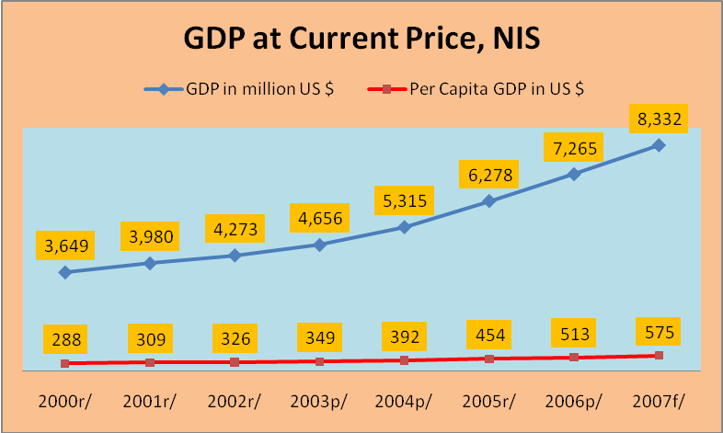

Source: NIS 2008

2.4 Health Status

According to WHO’s definition, health is complete physical, mental, social, and spiritual well-being. Health is one of the priority focus and cross-cutting outcomes of many government policies and strategies, such as Cambodia Millennium Development Goals, the RS, the NSDP and the Health Strategic Plan (HSP). Provision of good health care services would have positive impacts on the achievement of the goals of other sectors, be of agriculture or fisheries. Rigorous efforts have been made for the last two decades to improve health care services and infrastructure, including setting up financing mechanism that benefits the poor and the disadvantaged across the country. As of 2007 there are 1,035 health establishments with 10,509 available medical beds. The total number of registered public health personnel is 16,541, of which 2,012 are medical doctors with an increase of 43.1% between 1997 and 2007.

Health outcomes have improved recently. The infant mortality rate has decreased from 66 per
1,000 live births in 2005 to 45 per 1,000 live births in 2010. The under-five mortality rate decreased from 83 per 1,000 live births to 54 per 1,000 live births in the same period. Life expectancy at birth is 60.5 years for males and 64.3 years for females (NIS, 2009). A total of 67,341 malaria cases (OPD) were treated in 2007, which has declined 12.3 percent from 76,829 cases treated in 2006 (HSP). Malaria fatality case per 100,000 population in 2003 and 2007 was decreasing from 9.96 and 7.9 respectively (HSP). General government expenditures on health per capita increased from US$4 in 2000 to US$7 in 2005 and US$11 in 2009 (WHO, 2011). The health status of the Cambodian people has steadily improved in a number of key areas. Nonetheless, challenges remain in many other areas, including potential health risk associated with changing climate variability and extreme weather.

Figure 3: Health Finance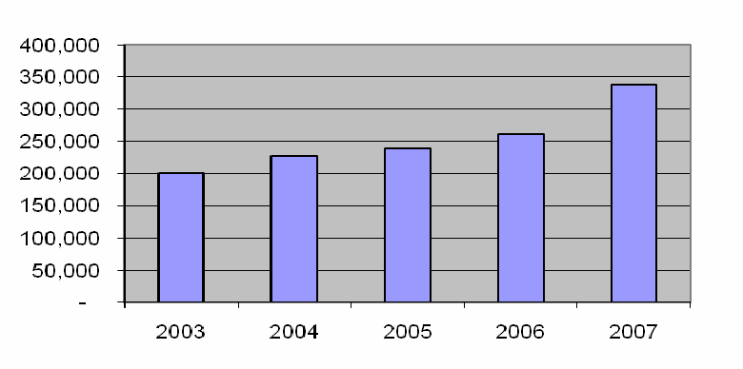

3. Climate Change Observation, Projection, and Health Implications

3.1 Climate Observation and Projection
The IPCC’s Fourth Assessment Report (2007) has observed that the global mean surface temperature has risen by 0.74°C for the last 100 years, and the warming rate is almost double for the last 50 years where land has warmed faster than the ocean. The surface temperature is projected to increase ranging from 1.8°C for a low scenario (B1) to 4°C for the highest scenario (A1FI) over the course of the twenty-first century based on a large number of different global climate models and a range of plausible scenarios of greenhouse gas emissions (Table 1, figure 5). In South-East Asia the mean temperature by 2100 is projected to increase 1.95°C under B1 and 3.77°C under A1FI from 1990. Based on analysis and modeling of the historical and future climate change of Cambodia using reconstructed data from PRECIS and GCM models under Scenario B1 and A2 (SNC, 2010), the rate of mean monthly temperature increase in Cambodia ranges from 0.013 °C to 0.036°C per year depending on the location. The rate of temperature increase is high in low altitude areas such as in central Cambodia and in the North East of Cambodia (0.036 °C per year) and low in the high altitude areas such as in South West region (0.013°C per year). Since 1960, the frequency of ‘hot’ days8 has increased significantly (+46, with strongest increases noted in September- November), as has the frequency of ‘hot’ nights (+63, with strongest increases noted in December-February).

Table 1: Projection of Surface Temperature and Sea Level Rise by IPCC Fourth Assessment Report
Scenario |  |  | Sea Level Rise  (m at 2090-2099 relative to 1980-1999 )
  Temperature Change
  (°C at 2090-2099 relative to 1980-1999)ª
Case | Best estimate | Likely range | Sea Level Rise  (m at 2090-2099 relative to 1980-1999 )
Constant Year 2000 concentrations ^{b} | 0.6 | 0.3 – 0.9 | NA
B1 scenario | 1.8 | 1.1 – 2.9 | 0.18 – 0.38
A1T scenario | 2.4 | 1.4 – 3.8 | 0.20 – 0.45
B2 scenario | 2.4 | 1.4 – 3.8 | 0.20 – 0.43
A1B scenario | 2.8 | 1.7 – 4.4 | 0.21 – 0.48
A2 scenario | 3.4 | 2.0 – 5.4 | 0.23 – 0.51
A1FI scenario | 4.0 | 2.4 – 6.4 | 0.26 – 0.59
Source: IPCC 2007

Figure 4: Projection of Global Surface Temperature Under Different Scenario by 2100
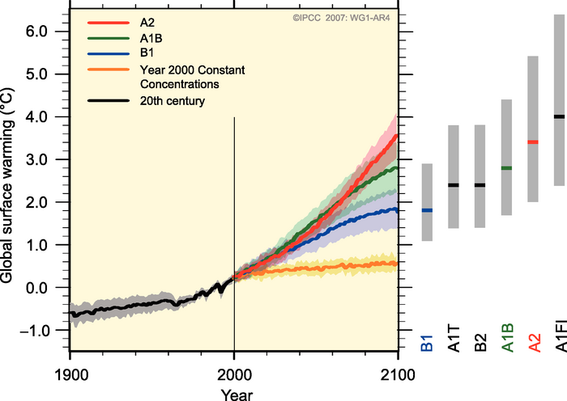
Source: IPCC Fourth Assessment Report

Table 2: Projection of Surface Temperature and Precipitation in South East Asia by IPCC
 | Sea-son | 2010-2039 |  |  |  | 2040-2069 |  |  |  | 2070-2099
 | Sea-son | Temperature °C |  | Precipitation, % |  | Temperature °C |  | Precipitation, % |  | Temperature °C |  | Precipitation %
 | Sea-son | A1FI | B1 | A1FI | B1 | A1FI | B1 | A1FI | B1 | A1FI | B1 | A1FI | B1
South-East Asia | DJF | 0.86 | 0.72 | -1 | 1 | 2.25 | 1.32 | 2 | 4 | 3.92 | 2.02 | 6 | 4
South-East Asia | MAM | 0.92 | 0.8 | 0 | 0 | 2.32 | 1.34 | 3 | 3 | 3.83 | 2.04 | 12 | 5
South-East Asia | JJA | 0.83 | 0.74 | -1 | 0 | 2.13 | 1.30 | 0 | 1 | 3.61 | 1.87 | 7 | 1
South-East Asia | SON | 0.85 | 0.75 | -2 | 0 | 1.32 | 1.32 | -1 | 1 | 3.72 | 1.9 | 7 | 2
Source: IPCC 2007.

Figure 5: Projection of Hot Days and Daily Heavy Rainfall by IPCC
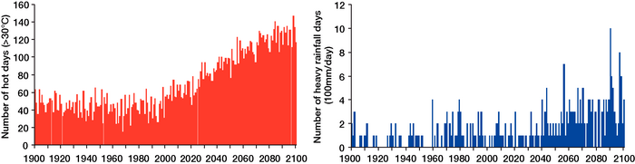
Source: IPCC Fourth Assessment Report on projected number of hot days (>30°C) and days of heavy rainfall (>100 mm/day) by the high resolution general circulation model (Hasumi and Emori, 2004).

3.2 Observation of Climate Change Impacts in Cambodia

As a result of modeling work of the INC and SNC team, Cambodia’s mean surface temperature has increased by 0.8°C compared to 1960 (SNC). This small change is very difficult for anyone to feel or apprehend the consequential health impacts since human can adapt to much higher fluctuation of temperature variables. However, what is more obvious to many people in Cambodia is an observed change of climate pattern attributing to increased flooding, droughts and wind storms in terms of frequency, severity and duration that have occurred for the last two decades. According to NCDM, flooding has been recorded almost every five years but become more frequent in the last ten years (in 1961, 1966, 1978, 1984, 1991, 1996, 2000, 2001 and 2002). Flooding in 2000 was the most severe flooding ever happening in Cambodia affecting million people, causing human death (347, 80% of which were children), and damaging social and physical infrastructure (US$150 million). Drought was observed in 2001, 2002, and 2003, where the drought in 2002 affected agriculture in 420 communes of 76 districts located in the 10 provinces of Prey Veng, Kandal, Kampong Speu, Takeo, Svay Rieng, Kampong Thom, Kampong Cham, Kratie, Odor Meancheay and Banteay Meanchey. Table 3 provides a summary of natural disasters happening between 1987 and 2007, which serve as a strong evidence of direct and indirect health impacts that may be associated with climate change (NCDM, 2008).

Table 3: Natural Disasters in Cambodia 1987-2007 (NCDM)
 | No of Events | Death | Injury | Homeless | Population Affected | Cost of Damage, in 000’s
Flood | 12 | 1,125 | 53 | 275,805 | 9,514,614 | 327,100
Avg. per event |  | 94 | 4 | 22,984 | 792,885 | 27,258
Drought | 5 | 0 | 0 | 0 | 6,550,000 | 138,000
Avg. per event |  | 0 | 0 | 0 | 1,310,000 | 27,600
Epidemic | 8 | 788 | 0 | 0 | 413,570 | 0
Ave. per event |  | 99 | 0 | 0 | 51,696 | 0
Source: National Strategic Action Plan for Disaster Risk Reduction 2008-2013

3.3 Health Vulnerability and Impacts of Climate Change

Several initiatives were undertaken to assess health vulnerability and adaptation (V&A) in Cambodia, which serves as an information base for identification of critical areas of climate- related health outcomes and devising appropriate responsive strategies to reduce climate sensitive health burdens. Significant progress on V&A for health sector has been made by the MOE as part of the preparation of Cambodia Initial National Communication (2002), the SNC (2010), and the National Adaptation Program of Action to Climate Change (NAPA, 2006). Among 39 adaptation projects identified by NAPA six were health-related adaptation projects. The INC has developed the regression model to establish mathematical correlation between malaria incidents and climate variability as shown below.

Y = 24268 – 1.37 DSR + 1.55 WSR – 103 Tmean – 342PL
Where DSR: dry season rainfall, Nov. to April; WSR: wet season rainfall, May to Oct.; Tmean: annual mean temperature; and PL: percentage of literate population.
The above equation indicates that the number of malaria cases is negatively correlated with dry season rainfall, means of annual temperature and percentage of literate population, and positively correlated with wet season rainfall.

The SNC team continues to improve modeling of climate change impacts and malaria incidents by conducting two analysis (i) assessment of proneness of provinces to malaria based on historical malaria data of 2000-2005 from MOH and (ii) assessment of malaria transmission risk under current and future climate.
Assessment of the Proneness of Cambodia Provinces to malaria was conducted based on five types of malaria indicators:
- Percentage malaria confirmed case (M). Number of confirmed malaria cases reported by every province and divided by the total confirmed malaria cases of all provinces and multiplied by 100;
- Trend of the M value over 6 years (TM). The trend value was estimated using regression equation;
- Percentage number of death caused by Malaria (N). Number of death case caused by malaria reported of every province divided by the total death cases of all province and multiplied by 100;
- Trend of the N value over 6 years (TN). The trend value was estimated using regression equation;
- Percent population at risk (PR). Number of population at risk reported by every province and divided by the total death cases of all province and multiplied by 100.
Assessment of malaria transmission risk under current and future climate follows the transmission risk formula of Reiter (2001).
$$c=\frac{{\text{ma}}^{2}p^{n}}{−\text{ln}p}$$
where ‘m’ is the mosquito density per human, ‘a’ is the average number of bites per day for each mosquito, ‘p’ is the probability of a mosquito surviving through any one day and ‘n’ is the extrinsic incubation period—the time taken for the pathogen to develop in the mosquito until the insect becomes infective.
Based on Malaria Proneness Index (MPI) and five clusters of proneness areas a map was prepared as shown in figure 6.

The MPI has indicated that Batambang has the highest M (13%), then followed by Pursat, Kompong Speu and Preah Vihear. While Kandal, Sihonoukville, Phnom Penh, Svay Rieng, Takeo, Kep, and Prey Veng have the lowest M values. It is suggested that most of provinces (19 of the 24 provinces) showed decreasing trend of the M value over 6 years.

Figure 6: Map of Proneness Areas to Malaria

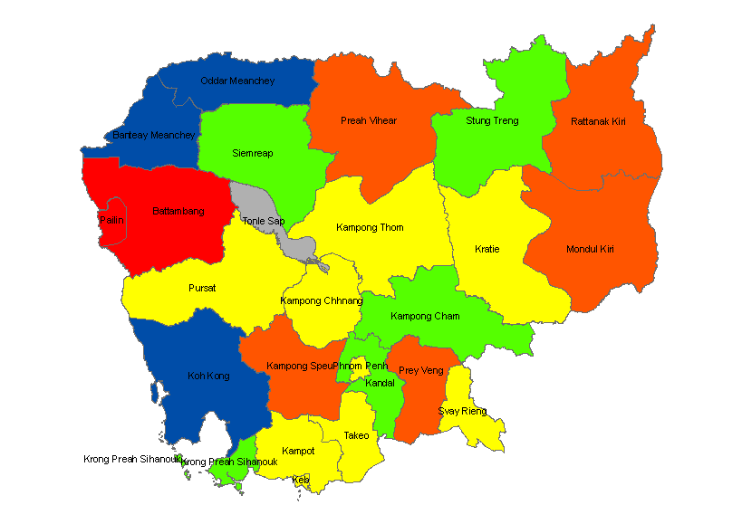
Source: V&A Assessment for health sector by SNC, 2010

It is important to note that both INC and SNC have a focus on analysis of malaria incidents in relation to climate change variability, which may not represent the full picture of potential health impacts, therefore expansion of this modeling techniques for the analysis of health risks associated with other climate related health incidents such as dengue fever, water/food borne diseases and extreme natural disasters would improve understanding for devising comprehensive health adaptation planning and policy response. In addition to the short time series data, other factors e.g. humidity and people migration, are not included in the analysis, therefore additional studies and surveillance is needed to generate statistical data for better modeling purpose.

Health V&A assessment was also conducted in 2010 by the Ministry of Health (MOH) with the support of World Health Organization (WHO) through the Department of Preventative Medicine (DVM). An assessment process was adopted as the following:

- Identification of relevant stakeholders;
- Description of current burden of climate-sensitive health outcomes, including the populations and regions that are most vulnerable;
- Description of how current burden of climate-sensitive health outcomes are likely to change over coming decades irrespective of climate change;
- Description of the effectiveness of current programs and activities;
- Estimation of the possible additional burden of adverse health outcomes due to climate change;
- Identification and prioritization of public health and health care interventions to reduce likely future health burdens; and
- Identification of strategies to implement, monitor and evaluate the burden of climate-sensitive health outcomes and interventions to address these burdens, ensuring continued effectiveness in a changing climate.

As a result of the V&A assessment following the steps described above and based on IPCC Fourth Assessment Report (2007), the main impacts of climate change on health in Cambodia have been identified in four sensitive areas:
- Vector-borne diseases (e.g. malaria, dengue fever...);
- Water and Food borne diseases (diarrhea, typhoid, cholera…); and
- Food Security (malnutrition);
- Health consequences of extreme weather events (death, injury, damage, vector borne and water borne disease).

Understanding of the health impacts related to vector borne diseases has been improved, however little is known about the relationship between health impacts and water borne diseases and extreme weathers. The health statistics of the MOH has revealed an alarming number of water-borne disease contracting cases accounted for about 47 cases per 1000 population, where 41% of all patients were children with age below 4 years. It is difficult to associate these diseases with climate change since no systematic collection of climate variables in parallel with water borne disease incidents.

Figure 7: Statistics of Water Borne and Food Borne diseases in 2011
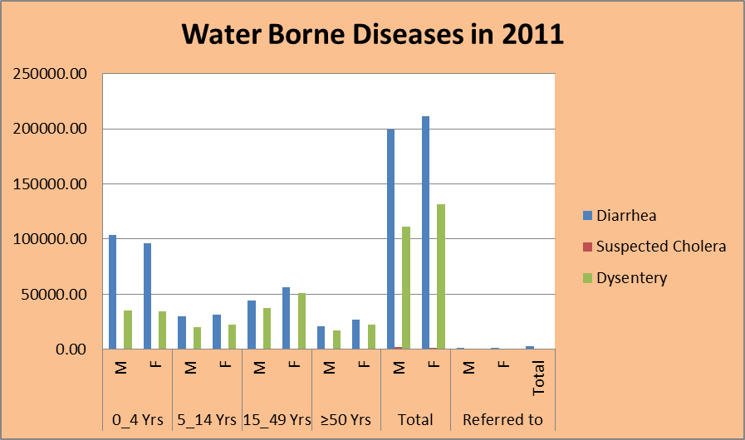

3.4 Methodology for Preparation of Climate Health Strategy and Action Plan

For the purpose of preparation of this Climate Change Strategy for Public Health (CCSPH), a
number of simple steps has been proposed as the following:
- Desk study of the government policies and strategies related to climate change and health sector, including existing studies and analysis of current and projected climate change impacts on health;
- Identification and scoping of the key climate health sensitive targets for the CHSAP;
- Development of CCSPH and priority health adaptation options built on HSP and NSDP through broad consultation with relevant stakeholders.

4. Health Policy and Response to Climate Change

4.1 Government Health Policies and Strategies

The Health Strategic Plan 2008-2015 was developed in 2008 with a broad vision “to enhance sustainable development of the health sector for better health and well-being of all Cambodian, especially of the poor, women and children, thereby contributing to poverty alleviation and socio-economic development.” The HSP comprises three goals: to reduce newborn, child and maternal morbidity and mortality with increased reproductive health; to reduce morbidity and mortality of HIV/AIDS, Malaria, Tuberculosis, and other communicable diseases; and to reduce the burden of non-communicable diseases and other health problems. All three goals are of relevance for health response to climate change, particularly Goal 2. The HSP has developed a set of monitoring indicators for measuring the success of the plan.

Consistent with these goals, the health strategy has identified five strategic areas: i) health service delivery; ii) health care financing; iii) human resource for health; iv) health information system; and v) health system governance. Several elements consistent with climate change issues and response can be found among a set of policy directions identified in the HSP
- Implement pro-poor health financing systems, including exemptions for the poor and expansion of health equity funds, in combination with other forms of social assistance mechanisms.
- Strengthen and invest in health information system and health research for evidence based policy-making, planning, monitoring performance and evaluation.
- Prevent and control communicable and selected chronic and non-communicable diseases, and strengthen disease surveillance systems for effective response to emerging and remerging diseases.
- Strengthen public health interventions to deal with cross-cutting challenges, especially gender, health of minorities, hygiene and sanitation, school health, environmental health risks, substance abuse/mental health, injury, occupational health, disaster through timely response, effective collaboration and coordination with other sectors.

4.2 Health Institutional Structure Relevant to Climate Change Response

The Ministry of Health is one of the big public institutions with extensive network of health care centers and facilities across the country. Its annual budget ranks second after the Ministry of Education, Youth and Sport that employs around 16,500 medical staff. Several central departments and centers established under the umbrella of MOH being more or less relevant to climate change include:
- Preventive Medicine Department (disaster and environmental health management and non-communicable diseases);
- Health Planning and Health Information Department (Health Financing and Health Information Database);
- National Malaria Center (CNM, malaria and dengue)
- Communicable Disease Control Department (HIV, Malaria, TB, Dengue, Chikungnya, EV, new emerging diseases;
- National Center for Health Promotion (NCHP)
- Food and Drug Department (food safety and drug registration and regulation);
- Hospital Services Department (role and responsibility of HC and RH)
- National Maternal and Child Health Center (NMCH) located in the Japanese-Cambodian Friendship Hospital.
The CDC and NMC are of particular relevance as far as vector-borne disease is concerned. The NMC has an ambitious goal of full elimination of malaria incidents by 2025 stipulated by the Prime Minister Decision. It has received approximately US$ 20 million from donors to combat malaria, which covers about 70% of overall malaria activity financing (NMC). The NMC has its extensive network down to the village level (village malaria workers), which facilitates information flow between villages and the NMC and distribution of treated nets and appropriate anti-malaria drugs. As a result the number of malaria incidents has decreased over the last decade as shown in figure 7 below. Still the NMC faces a number of constraints, notably the population movement and increase of dengue fever contracting cases.

Figure 8: Map of Malaria incidents in 2010 by NMC
Less attention is given to water borne and food borne disease and emergency responsive plan by the FDD and PMD. A common gap among relevant departments mentioned above is a limited knowledge and understanding of climate change impacts on health outcomes, modeling and projection techniques supporting V&A assessment and adaptation planning. Usually local climate variables are not included in the existing surveillance and researches, e.g. on epidemiology and entomology, therefore it is difficult to construct a reliable modeling on relationship between climate change and disease incidents in Cambodia.

It is worth noting that there is a good commitment of the political leaders of the MOH in addressing climate change issues affecting public health. Two working groups were setup to work on climate health related projects as the following:
  - Inter-ministerial Working Group was setup by Prakas for a Project “Climate Change and Vector-borne disease” supported by KOICA, is complete in 2011.
  - Climate Working Group for Health (CWGH) for the preparation of Climate Change Strategic Plan for Public Health (CCSPH) was setup by MOH’s circular consisting of the relevant departments above.
The CWGH may become a permanent body of the MOH which can facilitate and coordinate preparation and implementation of CCSPH, including capacity building activities. Appropriate training can be given to the CWGH so that they can become the trainers of trainees to pass the knowledge to the other medical staff.
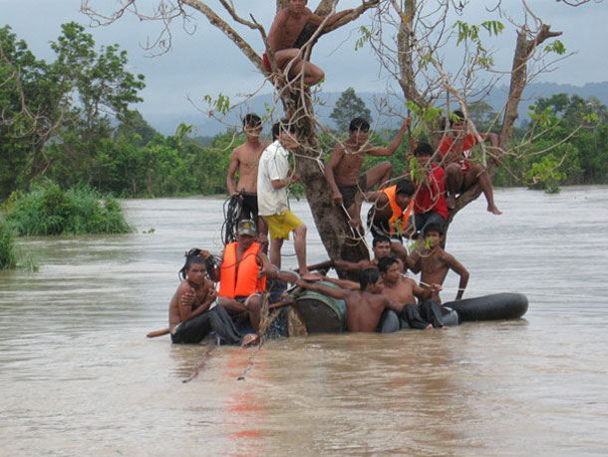

5. Climate Change Strategic Plan for Public Health

5.1 Vision, Goal and Objectives
Following consultation with relevant departments of the MOH, desk study of the health policy documents and a review of the existing analysis and studies by INC, SNC team and WHO, three climate-health sensitive areas are selected as the main targets for development of appropriate climate strategy and action for the health sector. The three targets include: i) vector-borne diseases; water/food borne disease; and extreme weather. In conformity with HSP and CMDG, Vision, Mission, Goal and Objectives are devised to address the three targets as described below.

  - Vision: to increase climate resilience for better health and well-being of all Cambodian, especially of the poor, women and children, contributing to poverty alleviation and achieving Cambodia Millennium Development Goals.
  - Mission: to provide efficient and equitable health care services and to build adaptive capacity to cope with short and long-term climate change by mainstreaming climate change into Health Strategic Plan and National Strategic Development Plan.
  - Goals and Objectives

Goal: To reduce morbidity, mortality, injuries and health vulnerability to climate variability and extreme weathers.

Objective 1:
To improve health care infrastructure and capacity of health personnel to cope with vector-borne and water borne diseases in the context of climate change.

- Conducting surveillance on malaria and dengue fever in selected provinces to improve knowledge on climate variability change (temperature, rainfall, humidity) and epidemiologic and entomologic changes;
- Assessment of health care infrastructure at all levels (especially in the disaster prone areas) in response to climate change related diseases;
- Development and update of technical guidelines for diagnosis, detection, control, prevention and treatment of diseases (malaria, dengue fever, diarrhea, typhoid, cholera…), injuries and other food poisoning illness arising from climate change;
- Development of short and long term incremental action plan for improved health infrastructure, staffing and capacity to cope with vector-borne and water/food borne diseases in the context of climate change built on strategic priorities stipulated in the Health Strategic Plan.

Objective 2:
To enhance emergency preparedness and response to cope with extreme weather and climate change related disasters.
- Development and implementation of surveillance of extreme weather related diseases, injuries, malnutrition, food safety/consumption in synergy or collaboration with Red Cross, NCDM, MOWRAM and other relevant agencies;
- Setting up and strengthening emergency preparedness and response network and plan, including food safety response, at all levels.

Objective 3:
To improve knowledge and research capacity on health impacts and vulnerability to climate change as an information base for mainstreaming climate change in the health strategic planning of the Ministry of Health and other sectoral planning.

- Development of methodologies, guidelines, models and indicators for research and health vulnerability assessment in collaboration with CCCD of the MOE, WHO and other relevant health institutes such as Pasteur;
- Organizing trainings on health impact/vulnerability assessment, modeling of climate variability and health impacts, surveillance and research based on needs…;
- Development of short and long term action plan for epidemiologic and entomologic research, surveillance and health vulnerability assessment in the context of climate change in priority areas to build science-based knowledge for adaptation planning and decision making;
- Promoting public education and awareness campaign through different means on health impacts of climate change, including disease control, prevention and treatment, epidemic preparedness, and sanitation and hygiene;
- Mainstreaming and regular update of climate change and health implications, including related adaptation plans in the Health Strategic Plan.

5.2 Strategic Framework

a. Strategic Analysis
Health outcomes are a common goal of many RGC national and sector policies and strategies. The key RGC policies and strategies that guide all sector planning including health sector are the Rectangular Strategy (RS), the National Strategic Development Plan 2010-2013 (NSDP), The Cambodia Millennium Development Goals (CMDG) and the Strategic National Action Plan For Disaster Reduction (SNAP-DR). The RS calls for improvement of health services as part of the Growth Rectangular 4 “Capacity Building and Human Resource Development”. Consistent with the RS, the NSDP has identified health priority actions and targets based on the Health Strategic Plan and calls for expansion of health care facilities by construction and/or rehabilitation of facilities, e.g. hospitals, health centres, etc., in rural areas. The CMDG comprises 9 Goals, where Goal 4, 5 and 6 are health related (Goal 4 “reduce child mortality”; Goal 5 “improve maternal health”; Goal 6 “combat HIV, Malaria and other diseases”). The SNAP-DR also identifies health issues important part of the Disaster Risk Reduction and calls for the assessment of hospitals that are located in hazard-prone areas, analysis of vulnerability of health facilities to these hazards, and development and implementation of hospital preparedness plan for all health facilities. In addition the HSP contains several elements supporting climate health response activities. Therefore, the CCSPH and adaptation framework has to be aligned with these policies and strategies and contributing to the overall achievement of health outcomes.

Change in world climate would influence the functioning of many ecosystems and their member
Species. Likewise, there would be impacts on human health (WHO, 2003). Some of these health impacts would be beneficial. For example further increase in temperatures might reduce the viability of disease-transmitting mosquito populations, but may favor propagation of water borne diseases such as typhoid and cholera. Overall, however, scientists consider that most of the health impacts of climate change would be adverse. Climate change was estimated to be responsible in 2000 for approximately 2.4% of worldwide diarrhea, and 6% of malaria in some middle-income countries (WHO, 2003). In Cambodia, the rate of malaria incidents has been declined for the last decade due to rigorous efforts taken by the MOH in collaboration with development partners. There is however a trend of the increase in dengue fever cases reported. Concerning water borne diseases, HIS of 2011 has estimated about 46 cases per 1000 population which is higher than malaria incidents.

It is important to note that climate change is a slow process occurring over many decades thus the health impacts are more pronounced over the near term (IPCC, 2001). Short and medium term planning is more realistic and should take into account other non-climate factors, e.g. people migration, land use change and deforestation, irrigation development, human population density. Systematic surveillance and observation of many causal factors can improve understanding and devise appropriate response.

Knowledge gap can be complemented by involvement of experts and institutions specialized in the subject of concern. Planning must be cost-effective in terms of optimal use of available knowledge and infrastructure and allocation of resources for additional activities with a minimum cost. Since modeling of climate change have many uncertainties and may not occur as projected, no-regret options can benefit the society even climate does not change. IPCC (2007) has identified rebuilding public health infrastructure as “the most important, cost-effective and urgently needed” adaptation strategy. Other no-regret adaptation options include: public health training programmes; more effective surveillance and emergency response systems; and sustainable prevention and control programmes. A Cambodian slogan says “Better Prevention and Cure”, because prevention is always cheaper than cure.

Diagram of Health Adaptation Strategic Framework
Adaptation Targets | Vector-borne Disease | Water-borne Disease | Extreme Weather
Adaptation Program | Improved Health Service Delivery
Adaptation Program | Emergency Preparedness and Response
Adaptation Program | Knowledge and Research Capacity in V&A for Planning
Strategic Approach | Capacity Building
Strategic Approach | Cross-sectoral Coordination
Strategic Approach | Health Information Management
Strategic Approach | Health Financing Mechanism
Strategic Approach | Monitoring and Evaluation
Planning Principles | Participatory, Knowledge based, and Cost-effective Planning
Planning Principles | Synergy and Alignment with Government Policies and Plans
Planning Principles | No-regret or Win-Win Options

b. Health Strategic Response to Climate Change

b.1 Adaptation

WHO defines “Vulnerability” as a function of Cambodia’s exposure and sensitivity to climate and climate variability, plus the adaptive capacity of the population to adjust to future challenges, while “Adaptation” refers to strategies, policies and measures undertaken now and in the future to increase climate-sensitive health resilience. The Vulnerability and Adaptation (V&A) assessment describes the impact of climate change on health outcomes in Cambodia, and strategies for modifying these effects.

As elaborated in section 6.1 three climate-sensitive health areas are identified as the main targets for devising adaptation strategy and corresponding health adaptation options in Cambodia. Those targets are:
- Vector-borne disease;
- Water borne and food borne disease;
- Health impacts arising from extreme weathers.

Three interrelated objectives are proposed with a set of actions identified for each objective as described in section 6.1. Those objectives and actions would be relevant for many years to come, but they can be modified based on update knowledge and projected health outcomes following several years of its implementation. They can serve also as a guiding framework by which adaptation programs or interventions can be planned and implemented.

A matrix of specific adaptation options is proposed to illustrate the relevance of ongoing and new proposed projects/activities against potential climate change impacts in the respective areas of health concern (see table 6). This matrix was discussed at various consultation meetings and generally accepted, which can be used to identify most relevant adaptation projects and activities that can best address the health impacts. Detailed proposal of adaptation projects and activities can be further prepared outlining the rationale, objectives, expected outputs, inputs, cost, and implementation schedule. The adaptation projects can be prioritized based on multiple criteria analysis and cost benefit analysis to ensure cost effective response and project outcome. In 2010, a notable progress was made in preparation of detailed health adaptation proposals to combat vector-borne diseases by MOH in collaboration with WHO which can be refined and considered for funding. Those projects include:
- Malaria and Climate Surveillance;
- Focusing on Community Volunteers and Village Malaria Workers;
- Provision of Long Lasting Impregnation of Bed Nets and Residual Spraying;
- Dengue research;
- Strengthening the Dengue Surveillance System in the Provincial Hospitals;
- Dengue Prevention Project.

Table 6: Matrix of Health Adaptation Options and Projects/Activities
Adaptation Strategy | Vector-borne disease | Water-borne disease | Extreme Weather
Prevention | - Use of insecticide treated mosquito nets | - Sanitation and hygiene  - Nutrition and Vitamin A supplement  - Latrines  - Safe drinking | - Sanitation and hygiene  - Nutrition and Vitamin A supplement  - Latrines  - Safe drinking
Control | - Use of larvicidal and insecticidal spraying | - Improving infection control procedures to prevent spread of illness
Treatment | - Use of appropriate drugs | - Early treatment with oral rehydration fluid  - Improving access to health facilities | - Relevant to both vector-borne and water disease and food poisoning
Public Education | - Public health awareness on climate change impacts, disease control, prevention, and treatment | - Public health awareness on climate change impacts, sanitation and hygiene, treatment | - Public health awareness on climate change impacts, community preparedness, sanitation
Capacity | - Improved health care facilities, Staffing  - Research and V&A | - Improved health care facilities, Staffing  - Research and V&A | - Improved health care facilities, Staffing,  - Emergency response procedures
Knowledge Generation | - Epidemiology and entomology research  - V&A assessment of flood and drought,  - Data management  - Surveillance of Anopheles and Aedes sp. mosquitoes and examining their relationship with climate and weather  - Malaria and dengue fever surveillance | - Methodologies, guidelines and models  - Surveillance  - V&A assessment of flood and drought  - Data management  - Modeling of climate variability and health impacts  - Data management | - Surveillance  - Epidemic preparedness  - Data management  - Climate projections and early warning  - V&A assessment of extreme weather
Financing | - Government Budget  - Health Equity Fund  - Safety net  - Multiple Donors,  Bilateral  - Health Insurance | - Government Budget  - Health Equity Fund  - Safety net  - Multiple Donors,  Bilateral  - Health Insurance | - Government Budget  - Health Equity Fund  - Safety net  - Multiple Donors,  Bilateral  - Health Insurance

b.2 Mitigation
Mitigation refers to policy, strategy and activity that can cut green house gas (GHG) emission. In Cambodia, major source of GHG emission is attributed to some sectors, e.g. land use change and forest (LUCF), agriculture, energy, and transportation, where the former contribute about 97% of GHG emission (INC, 2002). The health sector does not belong to any of these sector and would not require mitigation analysis and identification of GHG mitigation options. However as far as energy use is concerned, the MOH can help reduce GHG emission in the context of energy use efficiency, which can result in reduction of energy cost and GHG emission. Environmental audit is normally conducted to assess the energy use in the buildings and to provide recommendations for efficient energy use. It is reported that Comin Khmer Co. Ltd. can carry out such audit with a potential reduction of 20% of energy use. Another potential GHG mitigation option for the health sector is the use of solar power in the remote areas where national grid is not available.

C. Cross-Cutting Strategic Approach

c.1 Cross-sectoral Coordination and Cooperation

Health is a cross cutting goal of many government policies and sectors therefore coordination is critical to ensure effective health outcomes. Several areas such as sanitation and hygiene, food security, early warning and emergency preparedness and relief, are the responsibility of the MRD, MAFF, MOWRAM, NCDM and Red Cross. Currently MOH has experienced good cooperation with NCDM by playing very active role in provision of health care services during and after disaster management and emergency relief. This mechanism can be used to address other problems related to health risks and impacts, e.g. sanitation, hygiene, water supply and food safety/security with those relevant agencies. Even public education or specific prevention programs on vector-borne and water borne diseases cannot be achieved by MOH alone and should be promoted through involvement of many actors at different levels, e.g. NGOs, Commune Councils, volunteer villagers. Many NGOs have a good reputation in successful implementation of activities for combating malaria with NMC and must be further encouraged. A good practice has been on the formation of village malaria workers in combating malaria across the countries, especially in the malaria prone areas such as in Ratanak Kiri. Additional mechanism can be explored in the form of Climate Health Network or Forum to serve as a learning platform for exchange of knowledge and experience among experts, specialists, managers and researchers.

c.2 Capacity Building
Since knowledge on climate change impacts and climate related health outcomes is generally limited in the health sector, capacity building is considered one of the immediate priorities in the design of adaptation framework. Several health departments have been identified relevant to the three areas of health concerns in the context of climate change, which currently the members of the Climate Change and Health Technical Working Group. A training plan should be developed based on need assessment to match specific adaptation activities. Not exhausted, a number of potential subjects for training include the following:
- Basic knowledge on health implications and outcomes caused by changing climate variables (temperature, humidity, rainfall, extreme weathers);
- Modeling and projection techniques (including regression analysis, multi-criteria analysis, cost benefit analysis) and health V&A assessment;
- Epidemiology and entomology research in the context of climate change;
- Data collection and management incorporating climate variables in HIS;
- Surveillance of Anopheles and Aedes sp. mosquitoes and examining their relationship with climate variables and weather.

c.3 Health Information System

The MOH has developed and maintained a good Health Information System (HIS) containing a lot of data related to all health care services and disease incidents for the whole country. The HIS is maintained under the Department of Health Planning which compiles reports from OD, RH and HC around the country. The HIS does not have climate change variables and indicators along with health indicators such as prevalence of dengue fever and malaria incidents, thus is not sufficient for climate-health analysis. There is attempt to acquire mobile weather equipments for specific surveillance activities under the support of WHO, since climate variables obtained from the current meteorological stations have high variation compared to the specific local climate of areas in question. The HIS can be improved by provision of appropriate training on collection and maintenance of climate variables, including data analysis and modeling.
It should be mentioned also that health information is part of the socio-economic survey undertaken by the NIS and other line agencies (MRD, NCDM, MOWRAM, MAFF). Therefore coordination and standardization of climate data and health indicators among institutions can help reduce the cost and provide accurate information for analysis, projection, monitoring and evaluation purpose. Data sharing among institutions remains a common constraint but can be resolved through better communication and dialogue.

c.4 Financing Strategy and Mechanism

The MOH has good experience in implementing several financial schemes and fee-exemption systems supporting a wide range of health care services across the country. Two funding schemes are established, namely Health Equity Fund (HEF) and Community Based Health Insurance (CBHI), which offer opportunity for the poor to overcome financial obstacles for qualified health care. The HEF and CBHI can be expanded to cover health care services in the context of climate change, since the poor are most vulnerable to climate change.

Table 6: Coverage of health financing schemes.
No | Coverage of health financing schemes | 2007
 | No health facilities have HEFs | 45
 | OD | 39
 | National hospitals | 6
 | No of cases covered by HEFs | 246,598
 | No of cases exempted | 1,300,025
 | No of CBHI schemes implemented | 9 ODs
 | No of CBHI beneficiaries | 45,282
Source: HSP, 2008.

Besides, the MOH has received funding support from several development partners for specific health care activities. For example, the NMC has received a proximate amount of about $20 million annually for combating malaria. Though the rule is strict, this funding can be expanded to cover some urgent health adaptation activities identified by this CCSPH, such as prevention and control vector borne diseases, conducting surveillance, and capacity building of officials. Potential funding can also be tapped from the CCCA Trust Fund for supporting urgent training activities for most relevant officials, especially those are members of the Health Working Group for Climate Change. Possible Special Health Fund for climate change can be developed with some potential donors such as UNDP, USAID, WHO, and AUSAID.

c.5 Monitoring and Evaluation (indicators, risk assumptions, risk management, logframe analysis)

The MOH has developed a set of core indicators for monitoring and measuring the success of HSP, which can be used for monitoring and evaluation of health indicators related to climate change. There are missing indicators regarding water-borne and food borne diseases, including health impacts of extreme weathers. Those missing indicators will be added to the core indicators, which will be defined based on the health statistics of the HIS. Furthermore, a set of monitoring indicators are developed at the vision, mission, goal, and objectives levels to complement the core indicators.

Table 6: Monitoring Indicators adapted from HSP, NSDP and CMDG
Selected Core Indicators | 2008 | 2009 | 2010 | 2011 | 2012 | 2013
Reducing malaria case fatality rate per 100,000 pop (MOH, NSDP) | 2.1 | 1.5 | 1.2 | 1.1 | 0.99 | 0.9
Reducing dengue hemorrhagic fever case fatality rate reported to public (MOH, NSDP) | 0.68 | 0.7 | 0.6 | 0.6 | 0.6 | <0.6
Reducing the under-five mortality (CMDG) | From 124 in 1998 to 65 per 1000 live births by 2015
Reducing infant mortality rate (CMDG) | From 95 in 1998 to 50 per 1000 live births by 2015
Reducing maternal mortality ratio per 100,000 live birth (CMDG) | From 437 in 1997 to 140 by 2015
Reducing malaria case fatality rate (CMDG) | From 0.4% in 2000 to 0.1 % in 2015
Increasing the proportion of population at high risk who slept under insecticide-treated bed nets (CMDG) | From 57% in 2002 to 98% in 2015
Decreasing the number of malaria cases treated in the public health sector per 1 000 population (CMDG) | From 11.4 in 2000 to 4.0 in 2015
Increasing the proportion of public health facilities able to confirm malaria diagnosis according to national guidelines with 95% accuracy (CMDG) | From 60% in 2002 to 95% in 2015
Decreasing the number of dengue cases treated in the public health sector per 1000 population (CMDG) | From 1 in 2001 to 0.4 in 2015
Decreasing the dengue case fatality rate reported by public health facilities | From 1.5% in 2003 to 0.3% in 2015
Reducing the number of water borne disease cases (diarrhea, cholera, dysentery) per 1000 population | 43 % in 2011to 20 in 2023
Increasing the proportion of health care facilities to confirm diagnosis of water borne diseases | To be estimated
Reducing overall climate epidemic related disease cases fatality per 100,000 population | 0.35 in 2007 to 0.2 in 2023

6. Conclusion

Climate change impacts are felt on many sectors and across all Cambodian population and society. Health is considered one of the sectors being highly vulnerable to climate change. There is strong evidence of impacts of climate variables on health outcomes in Cambodia. Most visible impacts are associated with vector borne diseases and extreme weathers. There is however a general lack of knowledge and understanding on the causal-effect relationship of climate variables with health impacts since health outcomes are the functions of both climate and non-climate factors. A notable progress has been made by INC and SNC team in modeling of the malaria incidents in relation to climate variables which is a basis for development of the CCSPH. Current HIS does not include local climate variables therefore may not be reliable for modeling health outcomes. Nevertheless, on a basis of precautionary principles, this CCSPH has been prepared using all possible information deriving from different sources such as IPCC, WHO, UNDP, ADB and Cambodia’s line agencies. Built on many government strategies and policies, the CCSPH provides a comprehensive policy framework with a focus on adaptation in response to climate change impacts over a short term and medium term horizon. This document can be modified after several years of implementation and update knowledge and new emerging climate issues.

7. List of References
- ADB, 2009 “Economics of Climate Change in Southeast Asia”.
- Council of Minister, 2004 “Rectangular Strategy”
- IPCC, 2001, “Third Assessment Report”.
- IPCC, 2007, “Fourth Assessment Report”.
- MOE, 2002, “Initial National Communication”.
- MOE, 2006, “National Adaptation Program of Action to Climate Change” (NAPA).
- MOE, 2010, “Second National Communication”, draft.
- MOH, 2008, “Health Strategic Plan 2008-2015”, a vulnerability and adaptation assessment.
- MOH, WHO, 2010, “Climate Change and Health in Cambodia”
- MOP, 2010 “National Strategic Development Plan 2010-2013”.
- MOP, 2010 “Cambodia Millennium Development Goals”.
- NCDM, 2008, “Strategic National Action Plan on Disaster Risk Reduction (2008-2013)”
- NIS, 2010, “Demographic and Health Survey”.
- NIS, 2008, “Statistical Year Book”.
- UNDP, 2011, “Cambodia Human Development Report”
- WHO, WMO, UNEP, 2003 “Climate Change and Human Health – Risks and Response”.

8. Annex

Table 8: SWOT Analysis on Health and Climate Change, (New York Hotel, Kampong Chhnang, 30 July 2012)
 | Vector-borne disease | Water-borne disease | Extreme weather
Strength | - A National Malaria Center  - National experts on malaria and dengue with good communication with international experts  - Good network with provincial RH and HC  - Department for Communicable Disease Control (CDC)  - National Strategy and action plan to fully eliminate malaria cases by 2025 (2011-2025)  - Support of NGOs and development partners  - National budget and funding by development partners (70%), with good funding policy  - Declining rate in malaria infection case | - Rectangular Strategy  - National program (policy and guidelines)  - Action plan  - Budget | - Existing structure  - Strategy  - Funding policy  - Plan (AOP)  - Human resources
Weakness | - Capacity on relationship of vector-borne disease and climate change  - Responsibility and limited coordination with relevant agencies  - Use of international funding follows strict rules and cannot be changed  - Government budget is limited and often slow  - General knowledge on climate change  - Lack of research and surveillance on climate change and vector-borne diseases  - There is no budget on climate change related activities  - Lack of understanding and participation of population  - Movement of people is a one of the challenges in controlling vector-borne diseases | - Food borne disease policy  - Limited funding and transportation  - Cooperation with other agencies  - Knowledge and human resources  - Communication network | - Coordination limited, fragmented and overlapped  - Scale of disaster is more than planned  - Limited knowledge on disasters  - Lack of mobility means during flooding  - Lack of safe drinking water supply in the remote and rural areas  - Limited knowledge on new diseases  - Limited incentives for local health personnel  - Limited early delivery of information and messages
Opportunity | - Global Fund allocates about US$20 million per year for malaria prevention and control (buying insecticide treated nets…)  - About 40 implementation partners (NGOs…) | - Capacity building of technical officers  - Develop action plan  - Increase awareness and commitment of the RGC and donors | - Disasters are government priority  - Participation of CRC, private and donors  - Increase scope on disaster preparedness (human resources, funding…)
Threat | - Global Fund can be stopped or reduced if the use of funding is not appropriate  - Rate of dengue fever cases increases  - Rate of similarly-dengue fever cases | - Outbreak of the diseases (Cholera…)  - Health impacts  - Loss of income and time | - Loss of property and crops  - Damage to infrastructure, affecting work, education and development  - All diseases  - Loss of life  - Moral trauma  - Malnutrition  - Poverty
Matrix of adaptation | - Agree with the table with minor suggestion | - Agree with the matrix with no additional idea | - Agree with the matrix
Training | - Training on the use and collection of climate change variability.  - Impact of climate change on health

Table 9: Logframe Analysis and M&E
Name of Activity | Descriptive Statement | Indicators | Means of Verification | Risk Assumption | Risk Management
Vision | To increase climate resilience for better health and well-being of all Cambodian, especially of the poor, women and children, contributing to poverty alleviation and achieving Cambodia Millennium Development Goals. | No of vector-borne and water borne diseases  No of child mortality and maternal mortality rate | MOH annual progress report  HSP Review Report,  CMDG progress report,  NSDP M&E report,  CDHS reports | Limited budget and financing,  Limited knowledge and capacity | Developed health financing mechanism  Capacity building  Improved health governance  NSDP and HSP include health impacts of CC
Mission | To provide efficient and equitable health care services and to build adaptive capacity to cope with short and long-term climate change by mainstreaming climate change in Health Strategic Plan and National Strategic Development Plan. | No of RH and HC is improved and equipped to deal with climate related disease  No of health adaptation activities are implemented  HSP and NSDP incorporate CC impacts on health | MOH annual progress report  HSP Review Report,  MDG progress report,  NSDP M&E report, | Limited budget  Inadequate staffing and capacity, especially at the provincial levels | Operational financing mechanism (HTF, government, donor, HEF, HCI, private)  Capacity building  Health governance  NSDP and HSP include health impact of CC
Goal | To enhance health care infrastructure, emergency preparedness and response, and climate change-knowledge-based health strategic planning. | No of HC upgraded and better equipped  No of personnel trained and | MOH annual progress report  HSP Review Report,  CMDG progress report,  NSDP M&E report,  Progress reports of programmes and projects | Limited budget,  Limited coordination,  Poverty  Limited qualified staff at the local levels | Increased government budget, contribution of donors, HTF, HEF  Capacity building plan is in place
Objective | - Improved health care infrastructure and capacity of health personnel to cope with climate related diseases. | No of RH and HC upgraded and better equipped  No of personnel trained and active  HSP incorporate infrastructure and capacity improvement plan. | MOH progress report  HSP Review Report,  NSDP M&E report,  NCDM reports  CDHS reports  Provincial reports | Limited staff incentives and motivation  Budget constraint  Limited knowledge and awareness among staff and rural people  Inadequate cooperation of other sectors | Increased government budget, contribution of donors, HTF  Capacity building plan is in place  Cooperation framework in place
Objective | - Enhanced emergency preparedness and response to cope with extreme weather and climate change related disasters. | EPR plan is put into practice  No trained personnel  Increased participation of health personnel dealing with extreme disasters | MOH progress report  HSP Review Report,  NSDP M&E report,  NCDM reports  CDHS reports  Provincial reports | Limited inter-agency cooperation,  Budget Constraint for the areas of concern | Increased government budget, contribution of donors, HEF  Capacity building plan is in place  Cooperation framework in place
Objective | - Improved knowledge and research capacity on health impacts and vulnerability to climate change as an information base for mainstreaming climate change&health into health strategic planning of the Ministry of Health and other sectoral planning. | Research methodologies, V&A and guidelines are developed and implemented  Information on health impacts are included in the HIS,  No Health V&A is implemented  HSP incorporate CC and health adaptation programs | MOH progress report  HSP Review Report,  NSDP M&E report,  Provincial reports | Budget constraint  Research capacity | Increased government budget, contribution of donors, HTF  Capacity building plan is in place

- References/Bibliography

Recent analysis conducted by MOH has revealed that Ratanak Kiri is the most malaria prone areas based on number of malaria incidents.
According to the specialists from NMC, people migration is the main constraint for effective malaria control.
According to IPCC, human being can better adapt to slow change in climate.
Household spending is US$25 per capita/year or 66 percent of all health expenditures, HSP, 2008.
Cost per capita is $0.5 and cost per HEF member is $1.40

